- Open your own laptop or desktop (or use an online PC hardware simulator if you don't have access to a real system) and identify the GPU model installed. Write down the GPU's brand, model number, and whether it is integrated or dedicated.
Answer:
Information | Example only
GPU Brand | Intel
GPU Model Number | Intel Iris Xe Graphics
GPU Type | Integrated

- Take a clear photo or screenshot of the cooling system (fan, heatsink, or liquid cooling setup) inside your PC or from a PC hardware simulator. Label the main cooling components and briefly describe their function.
Answer:
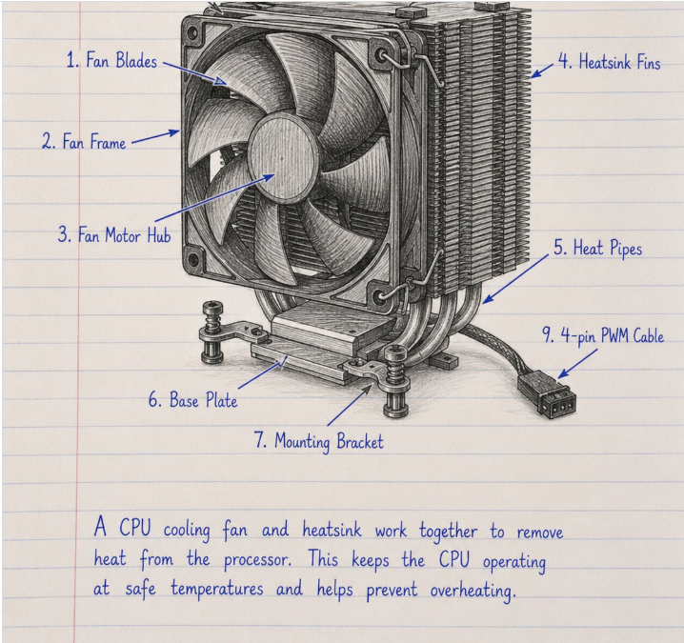
Fan:
- A PC fan (computer cooling fan) is a hardware component that keeps a computer cool by moving air through the system. It helps prevent the CPU, GPU, and other components from overheating.

Liquid Cooling System:
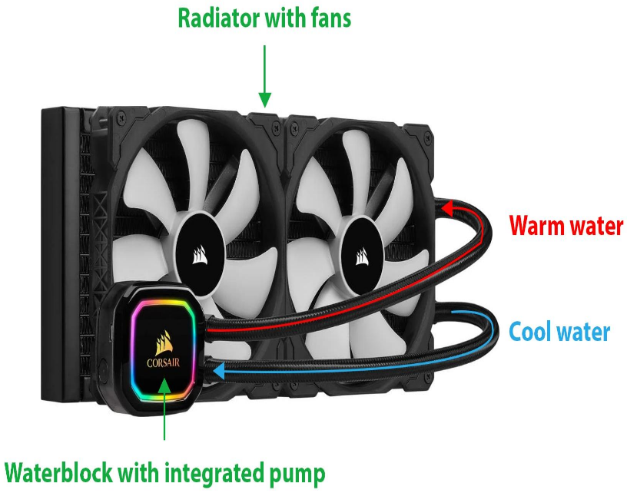
- A liquid cooling system is used to keep a computer's CPU or GPU cool. It uses a special coolant liquid to carry heat away from the processor and transfer it to a radiator, where fans release the heat into the air.

- Create a comparison table listing at least 3 differences between air cooling and liquid cooling systems for GPUs, including factors like cost, efficiency, and maintenance.
Answer:
Feature | Air Cooling | Liquid Cooling
Cooling method | Uses fans and a heatsink to remove heat from the GPU. | Uses liquid coolant, a pump, tubes, and usually a radiator to transfer heat away from the GPU.
Cost | Generally cheaper and more affordable. | Generally more expensive due to additional components.
Cooling efficiency | Effective for most GPUs and normal gaming. | Can provide better heat management for high-performance GPUs, depending on the design.
Maintenance | Usually requires cleaning dust from fans and heatsinks. | May require checking the pump, radiator, and tubes; custom loops need more maintenance.
Noise level | Fans may become noisy under heavy workloads. | Can be quieter in some setups, but pump and radiator fans also produce noise.
Installation | Usually simpler to install and maintain. | Generally more complex to install, especially custom liquid-cooling loops.
Risk of leakage | No coolant leakage risk. | Liquid cooling has a potential leakage risk, particularly in custom loops.

- Imagine you are building a gaming PC for streaming IPL matches and playing graphics-heavy games. Choose between air cooling and liquid cooling for your GPU, and justify your choice in 3-4 sentences based on your research.
Answer:

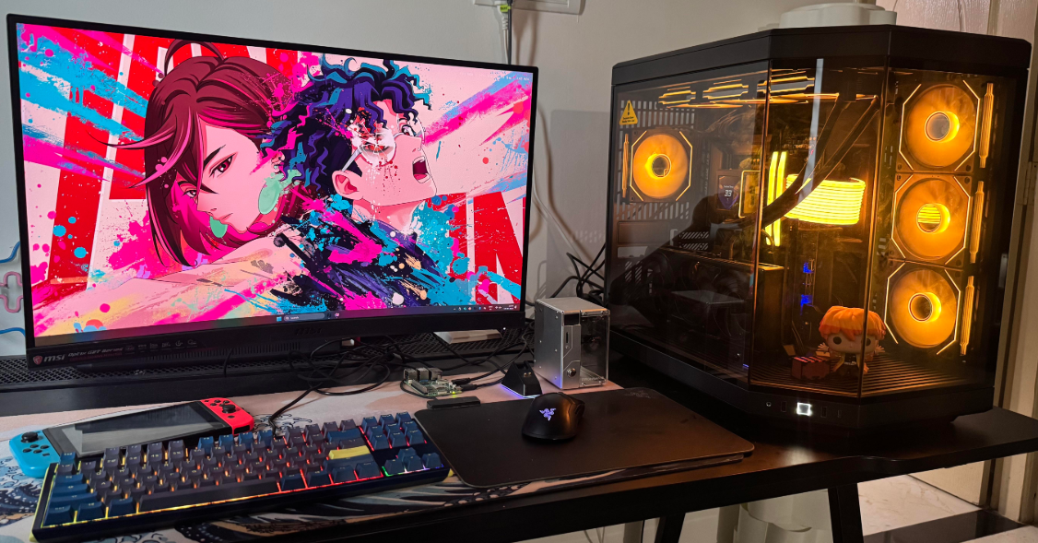
I would choose liquid cooling for a high-performance gaming PC used for streaming IPL matches and playing graphics-heavy games. It can help manage heat during long gaming sessions and may reduce fan noise, depending on the cooling design. Although liquid cooling is more expensive and more complex than air cooling, I would consider it for a high-end build where thermal performance is important. However, I would choose a GPU with a good factory-installed cooler or a compatible liquid-cooling solution.

